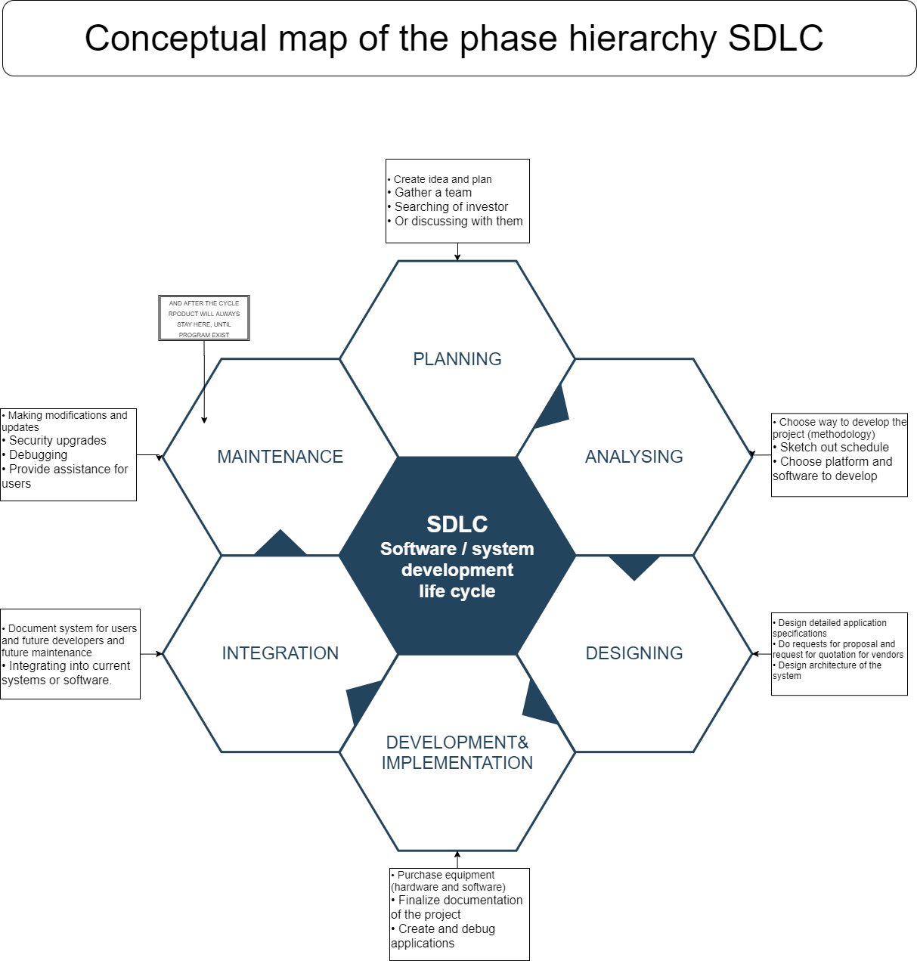

An SDLC is to help develop successful information systems. The SDLC or the system development lifecycle is a combination of stages through which system passes when developing. The one is supposed to be completed before the next phase can begin.

Planning, analyzing, designing, developing implanting & deploying, integration and maintaining or supporting. Many system development lifecycle models are based on the idea of saving money, time and effort, while minimizing the risk of non-compliance with customer requirements by the end of the development. It’s a good feature to control your SDP System/software Development Process.

Choosing the right SDLC model for your software or system development project will require careful thought. But keep in mind that a methodology for planning and guiding your project is one of the ingredients for success.